* 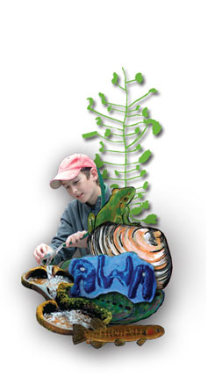

**THE BEST WAY TO PREDICT YOUR FUTURE IS TO CREATE IT**

**THE FUTURE IS NOW**

**DEAR FUTURE-I’M READY**

**THE FUTURE STARTS TODAY**

* **LOOKING AT THE FUTURE**
* **“KAITIAKITANGA - GUARDIANSHIP”**

**CUST SCHOOL GOALS / FOCI:**

LINKED TO CHARTER-GOALS-PD-APPRAISAL-SELF REVIEW

Strategic Area: Student Learning and Achievement

Writing – Cluster Project, moderation, programme of work,

Classroom programme, parent engagement

Maths – consistent, flexible maths teaching

Digital tech – Core PD

Maori responsiveness – profile – action plan

Portfolios / Inquiry – consistency, student voice

Appraisal – spiral of inquiry

**STUDENT TARGETS:**

Writing: By the end of 2015 at least 40% of all students will be achieving above the National Standard for writing

By the end of 2015 less than 10% of boys will be achieving below the National Standard for writing

Maths: By the end of 2015 at least 40% of all students will be achieving above the National Standard for Maths

By the end of 2015 less than 10% of boys will be achieving below the National Standard for Maths

**LITERACY / NUMERACY – FOUNDATION SKILLS**

**Literacy and Numeracy** describe a range of basic learning skills that we use in everyday life: reading, writing, speaking, listening, working with numbers, critical thinking, problem-solving, and using information technology (such as computers).

Literacy (reading and writing) and numeracy (mathematics and statistics) are the gateway to learning. Students need the necessary literacy and numeracy skills and knowledge to fully engage and achieve across all areas of the National Curriculum.

THEREFORE: We expect Literacy and Numeracy teaching and learning to be…..

**EXPLICIT & SYSTEMATIC BALANCED & INTEGRATED**

* 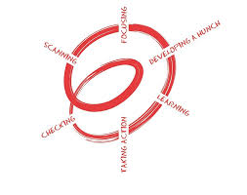

**Possible Contexts:**

Sustainability Jobs

History of Stuff Solar System

Farm to Table Citizenship

Ecosystems Transform

Diversity Gardens

Biotechnology Fair Trade

Container Paint Signage

Food Chains Consumption

Water Cycle Life

Earth Hour IT

Food Choices Air

Waste Goods / Materials Energy

Land Climate

Biodiversity EnviroWeek

Earth Systems Work

Communications

**DEEP UNDERSTANDINGS:**

**Students to …….theorise, generalise, hypothesise, reflect, generate (extended abstract verbs)….**

**..how we can act as guardians of the earths resources**

**..how we can confront issues and solve these**

**..how we can improve the future for us / school / community / world**

**..how we can take responsibility for the future**

**TAKING ACTION:**

**Taking Action is a process of learning:**

* **Uses meaningful contexts**
* **Empowers to do something with learning**
* **Supports participation**

**Examples:**

* **Personal response / behaviour change**
* **Project improve environment**
* **Development of system**
* **Project to educate others**

**Planning:**

* **What will students learn?**
* **What prior knowledge / understandings?**
* **How to ensure children are involved?**

**Template:  
Action Planner (EFS –NZ Curriculum)**

**Event:**

Transform – Art Display

Pet Day / Guy Fawkes – Friday 5 November

**OBJECTIVES:**

**Students will….**

* Investigate current issues and produce outcomes (explore future scenerio’s)
* Evaluate design ideas and outcomes
* Explore how outcomes are values
* Understand diversity of life and the impact of humans
* Understand Earths subsystems and the impact of humans

EFS – NZ CURRICULUM/

ENVIROSCHOOLS /GREENKIWI