Welcome to Term 2.

We started the term with our ANZAC Commemoration and Open Morning. The students learnt about ‘Torty’ the Tortoise who was rescued from under a French gun carriage in Greece in World War 1 and brought to New Zealand by a stretcher –bearer called Stewart. Torty has lived with Stewart’s family since that time and has had a few adventures of her own in New Zealand. The students take up the story:

Torty got run over by a French gun carriage and it broke her shell. She got lost and got stolen and sold to a circus and a Policeman found her and a soldier looked after her. She hibernated on the boat all the way back to New Zealand. When the soldier died his family now look after her.

Bianca

Torty is a tortoise. A French gun carriage left some marks on her shell and cut some toes off.

James

Torty got run over by a French gun carriage and lost some toes. She was stolen and was found in a circus. She nearly got herself burnt in a pile of leaves.

Max

The students also did some Poppy art modeled on paintings by John Nolan. Here are a few examples by Charlie, Ollie, Ruby and Thomas.

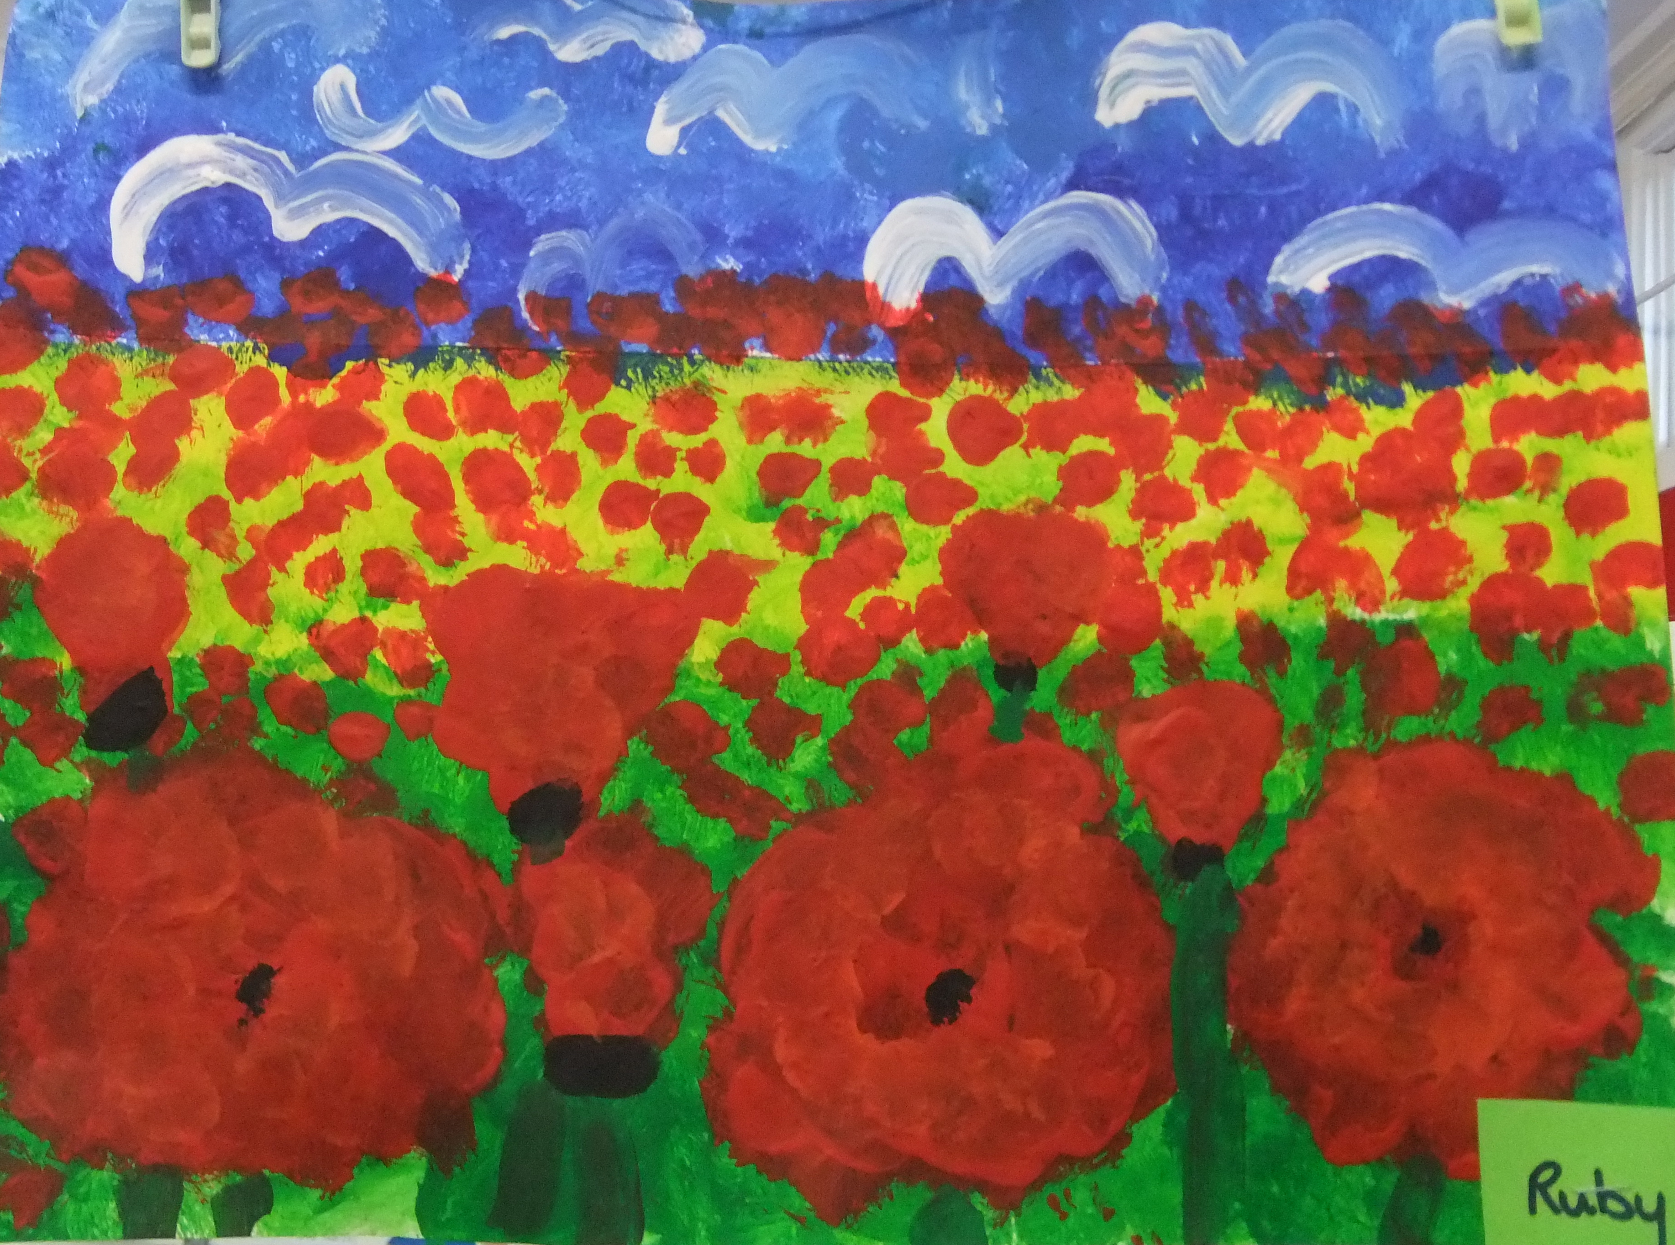
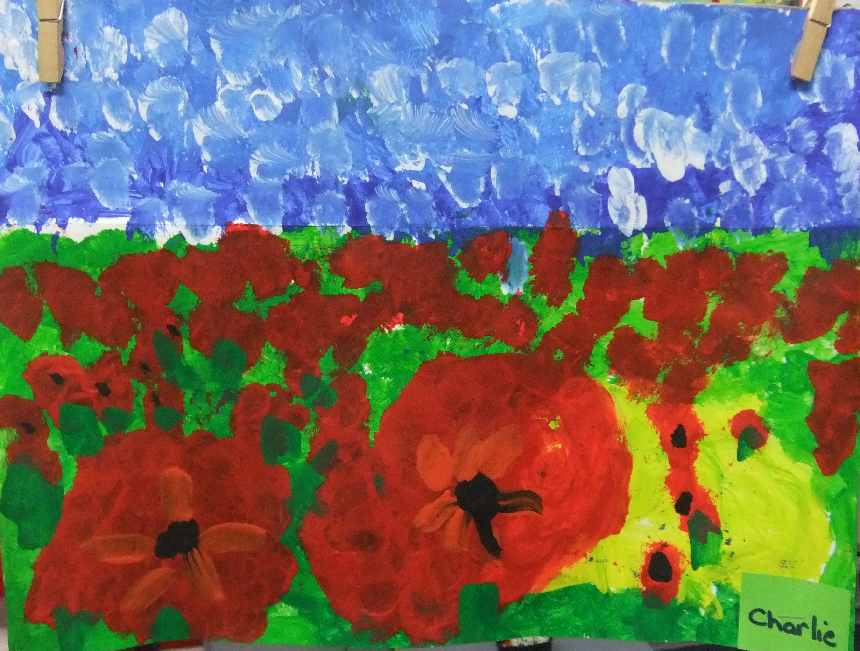

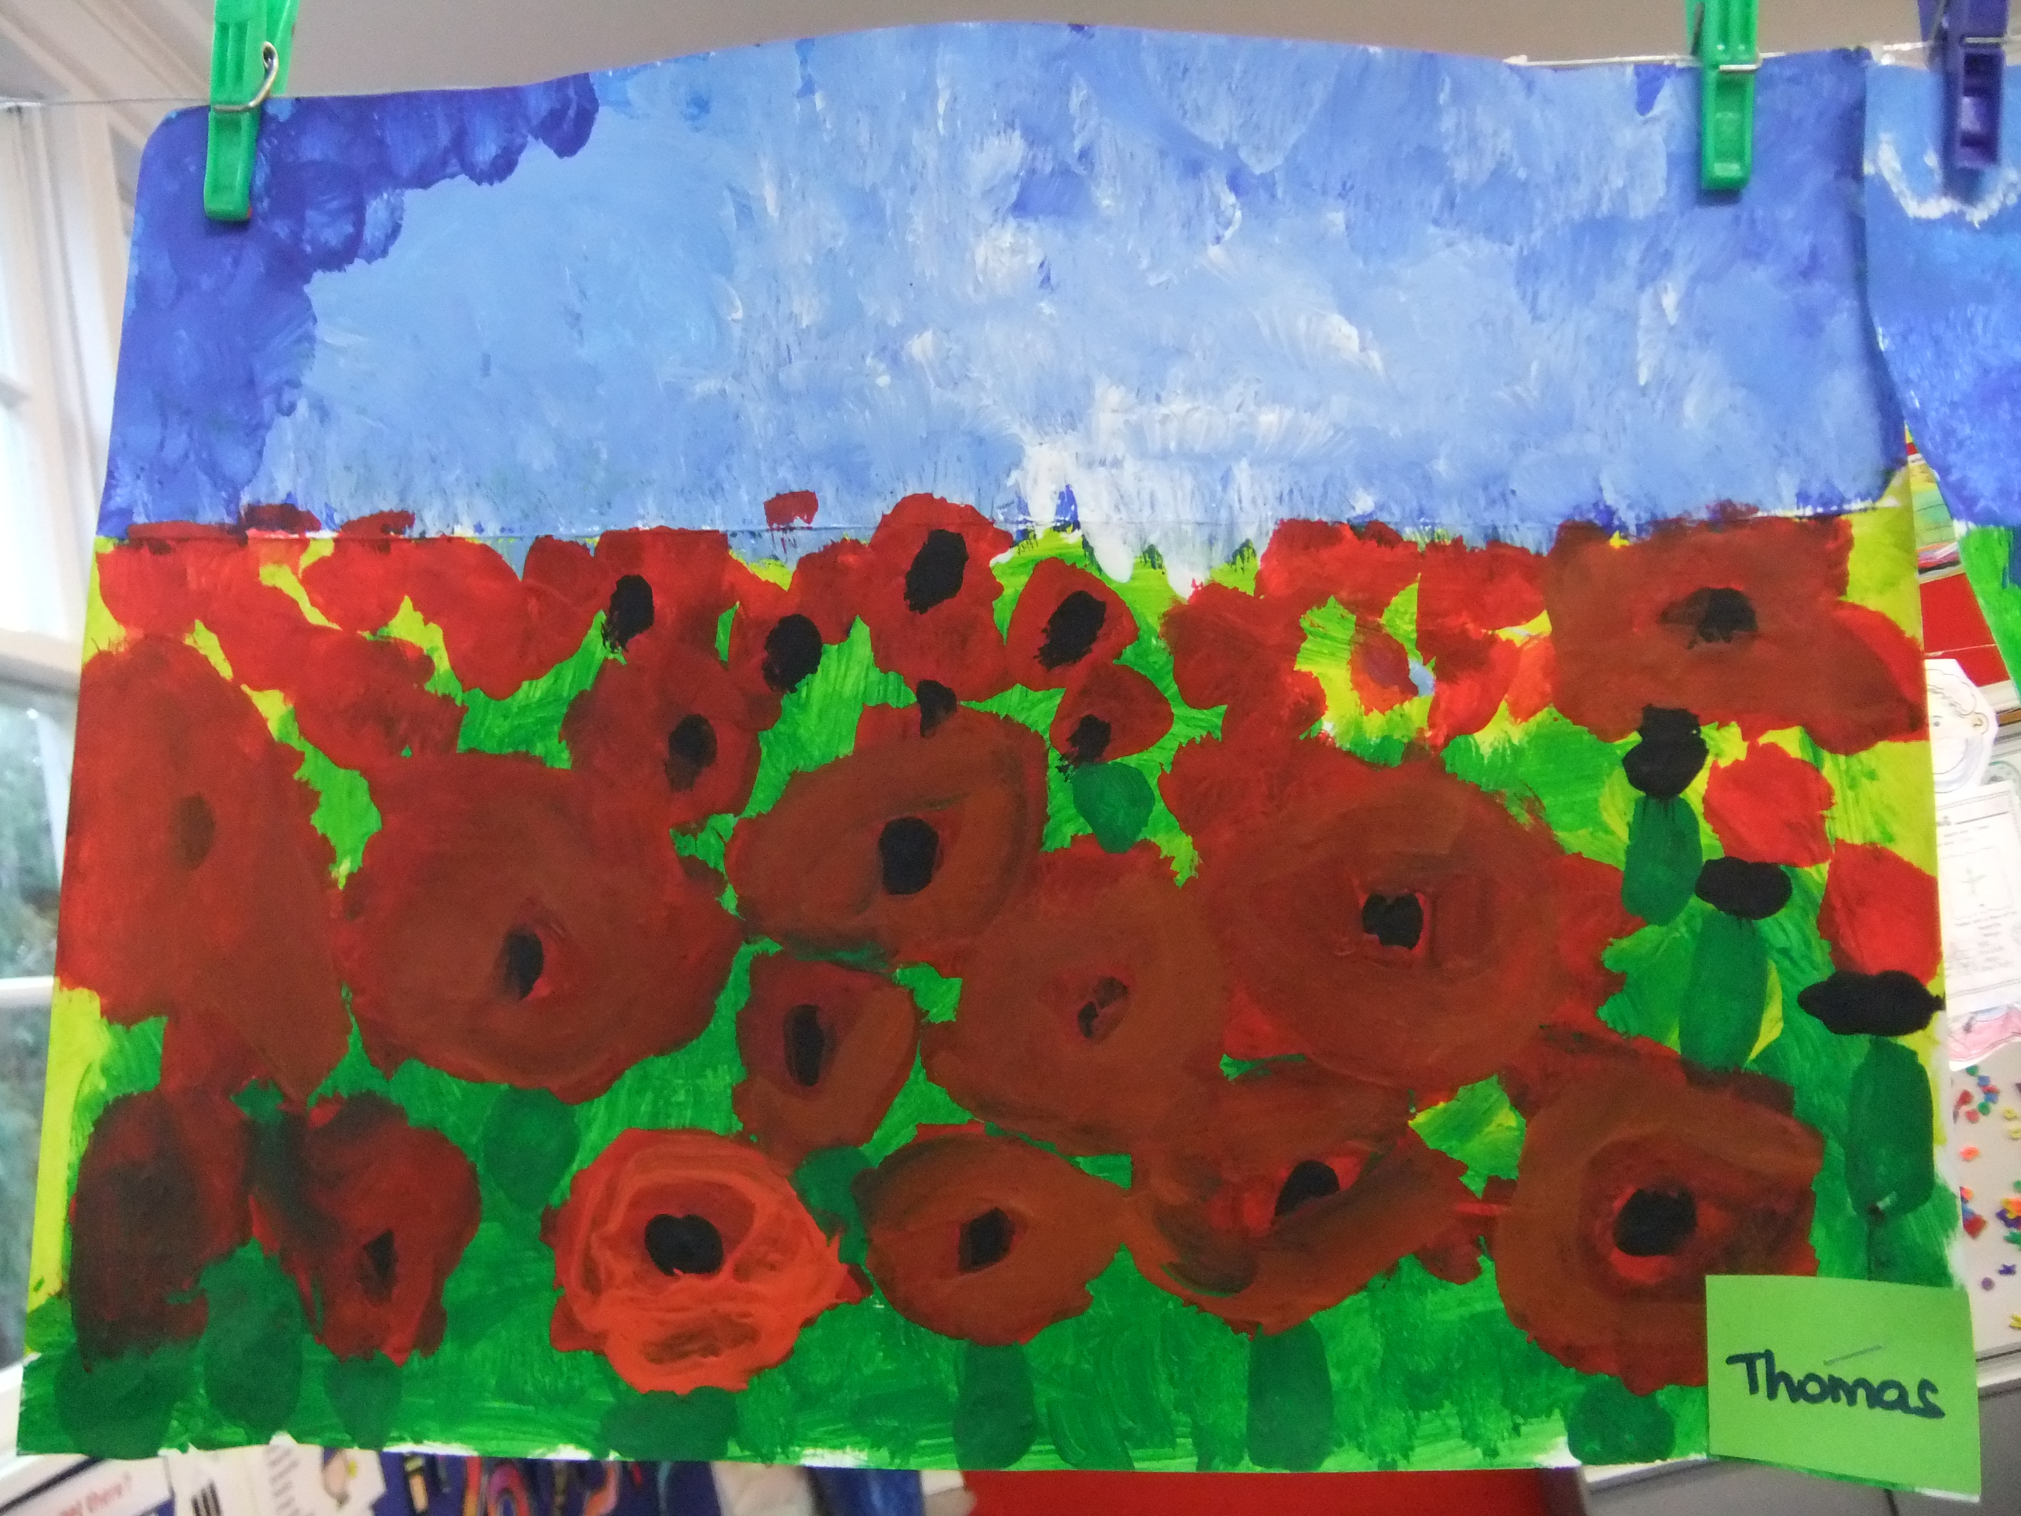
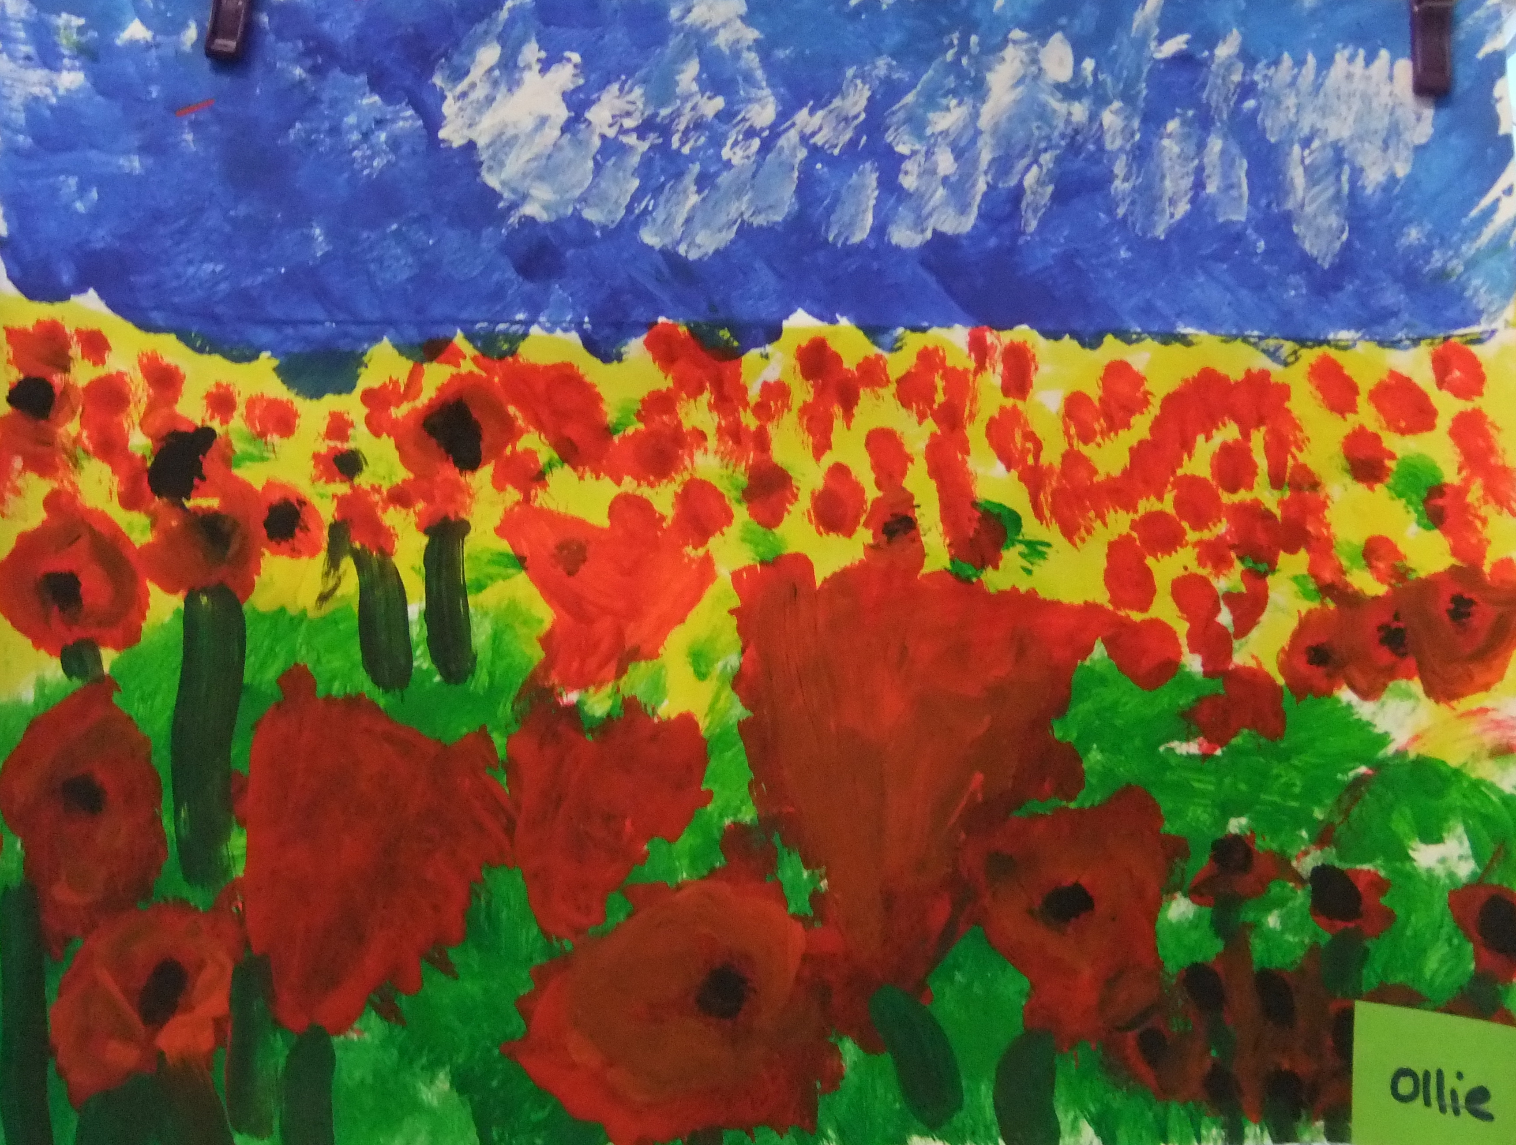

The students have also been training hard for the Cust School Cross Country and all showed how fit and healthy they were for example – Mia, Harry and Joshua.
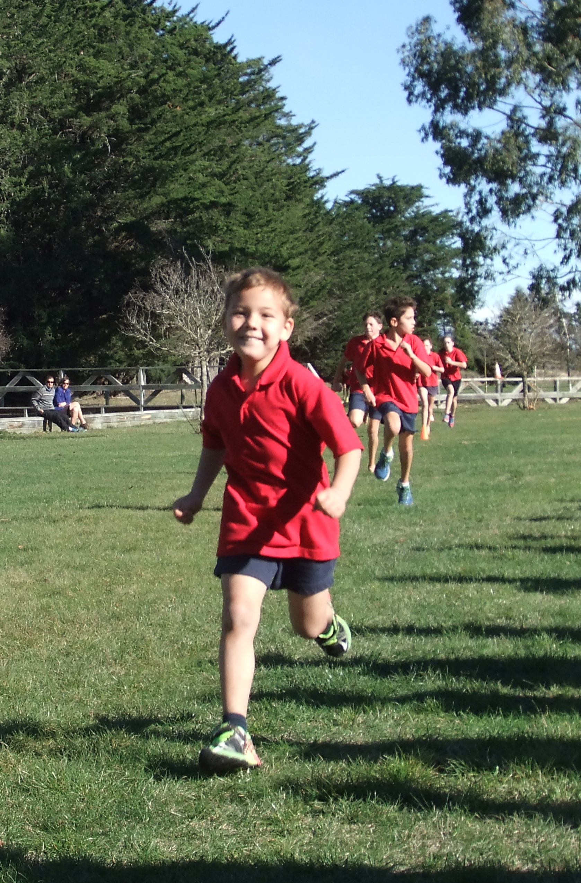
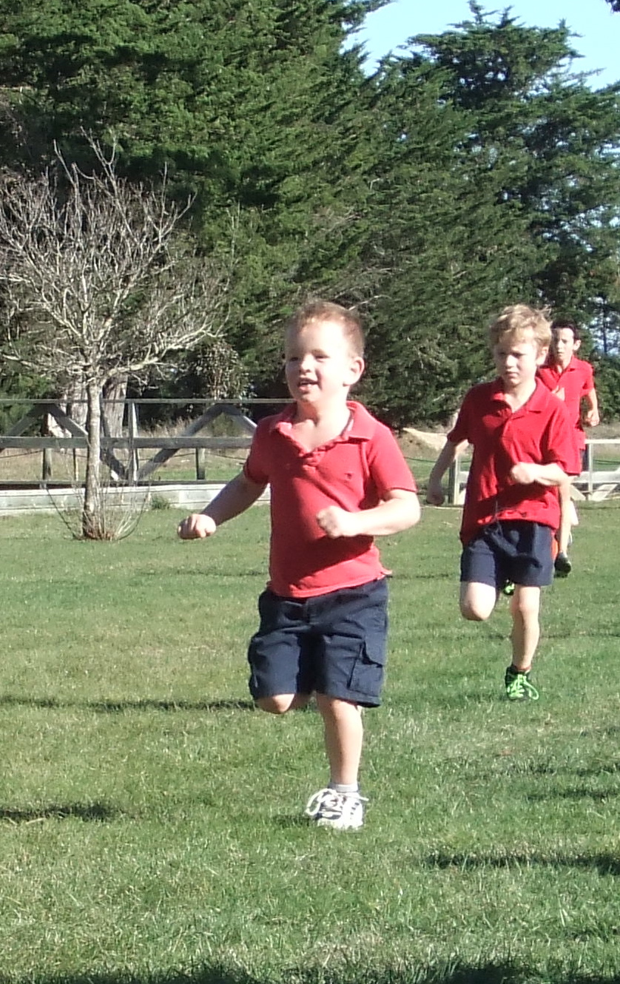
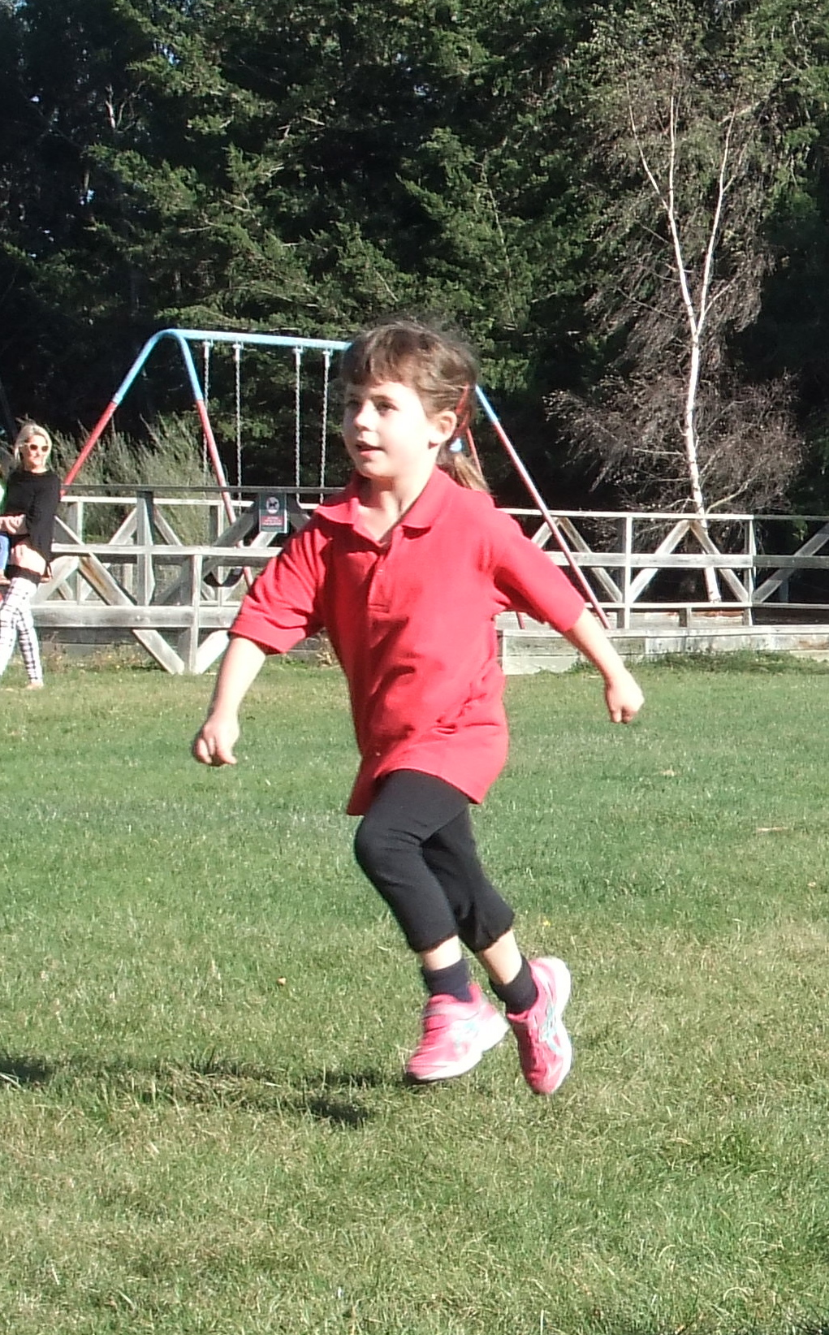

We have also had a visit from Life Education and the students were very pleased to see Harold the giraffe. The students learn about how they were all very important people.
